Best lambda for LBP is 18-22

Best lambda for HoG is 14

Data range shrink with best lambda

Male results

Result ground truth

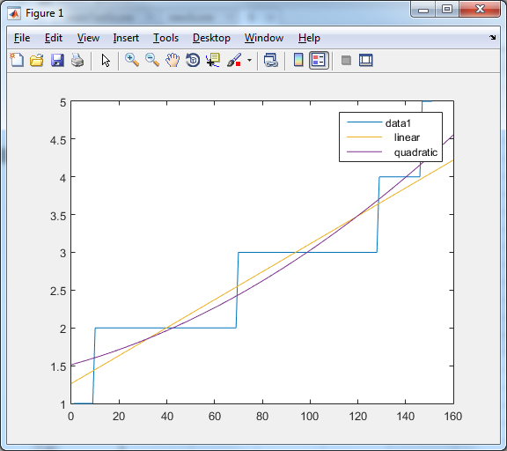

1. LBP feature /face size 500 /window Size 18*18 /lambda 0.001 /ground truth landmark

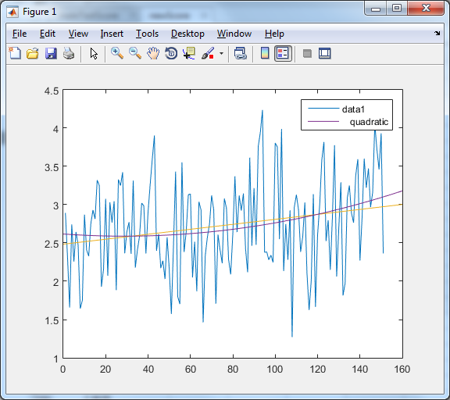

STD error (lambda = 0.001) = 0.9142

STD error (lambda = 0.01) = 0.9138

STD error (lambda = 0.1) = 0.9104

STD error (lambda = 0.5) = 0.8976

STD error (lambda = 1) = 0.8855

STD error (lambda = 5) = 0.8454

STD error (lambda = 12) = 0.8306

STD error (lambda = 18) = 0.8279

STD error (lambda = 20) = 0.8279

STD error (lambda = 22) = 0.8279

STD error (lambda = 25) = 0.8282

STD error (lambda = 37.5) = 0.8308

STD error (lambda = 50) = 0.8343

STD error (lambda = 60) = 0.8370

STD error (lambda = 75) = 0.8408

STD error (lambda = 100) = 0.8463

LBP feature /face size 500 /window Size 10*10 /lambda 0.001 /ground truth landmark

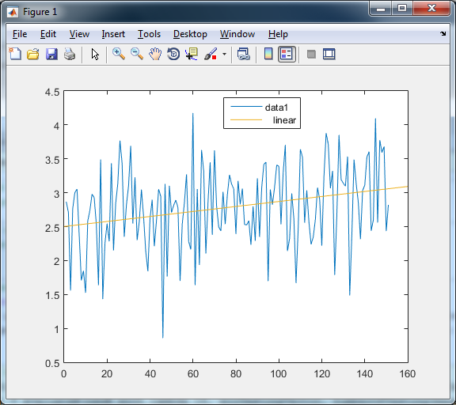

LBP feature /face size 500 /window Size 10*10 /lambda18 /ground truth landmark

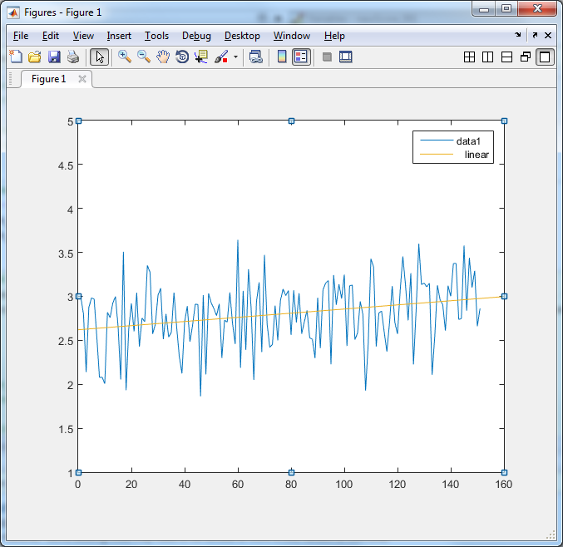

error_18 =

0.8669

error_10 =

0.8767

error_5 =

0.8911

error_1 =

0.9175

error_01 =

0.9282

error_001 =

0.9294

1. LBP feature /face size 500 /window Size 22*22 /lambda 0.001 /ground truth landmark

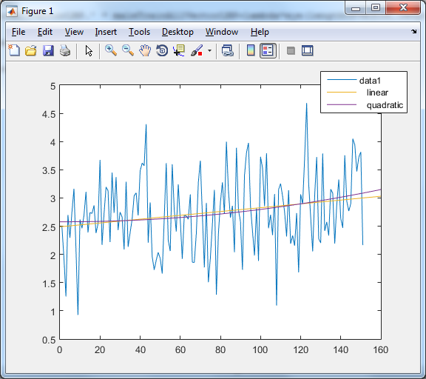

error_18 =

0.8351

error_10 =

0.8431

error_5 =

0.8615

error_1 =

0.9198

error_01 =

0.9592

error_001 =

0.9647

LBP feature /face size 500 /window Size 42*42 /lambda 0.01 /ground truth landmark 68vs49

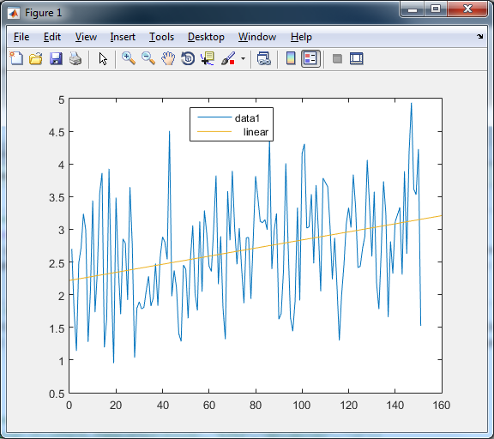s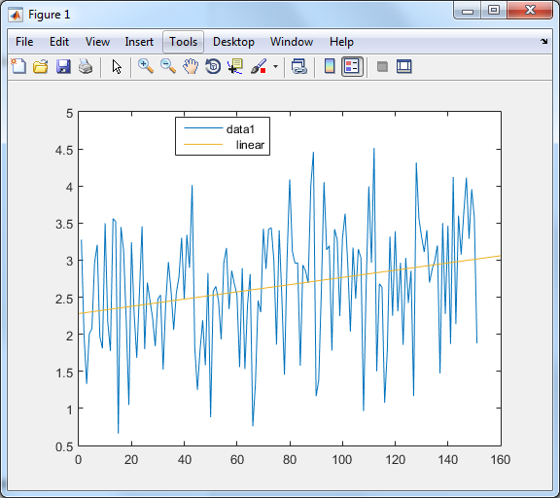

With offset

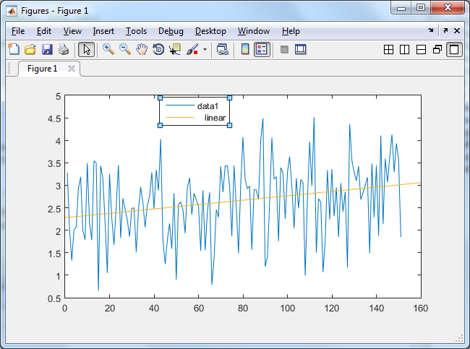

LBP feature /face size 500 /window Size 42*42 /lambda 18 /ground truth landmark 68vs49

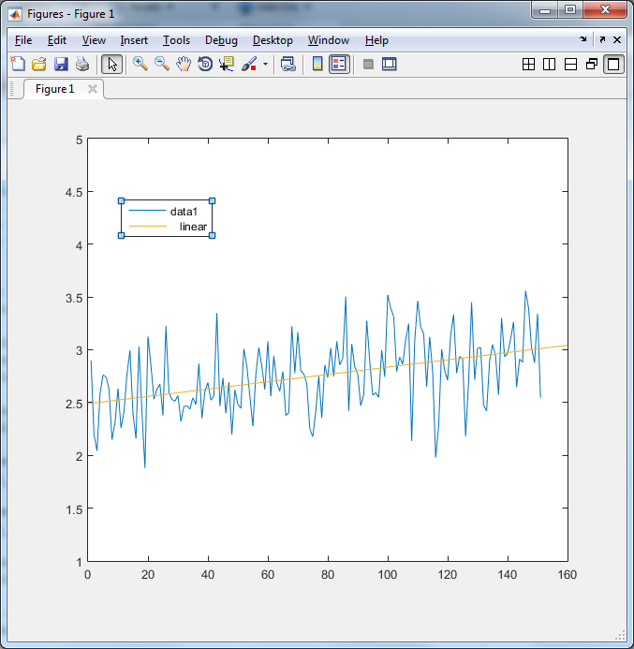

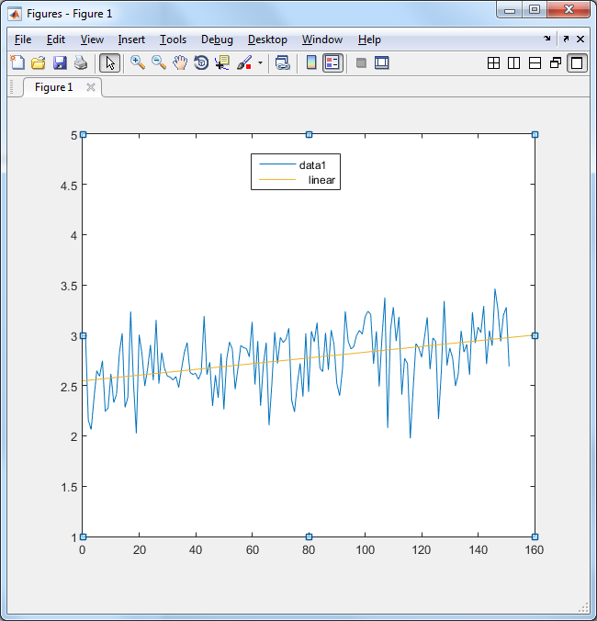

With offset

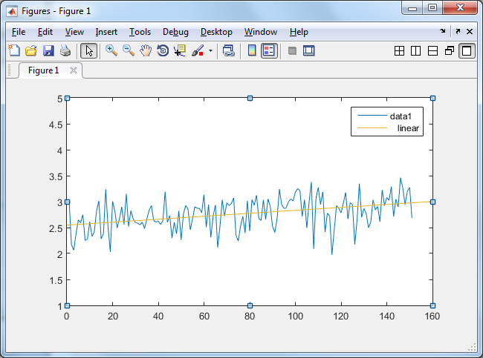

error_18 =

0.8129

error_10 =

0.8131

error_5 =

0.8214

error_1 =

0.8836

error_01 =

0.9664

error_001 =

0.9824

Using landmarks from GN_DPM algorithm

LBP feature /face size 500 /window Size 18*18 /lambda 18 /calculated landmark

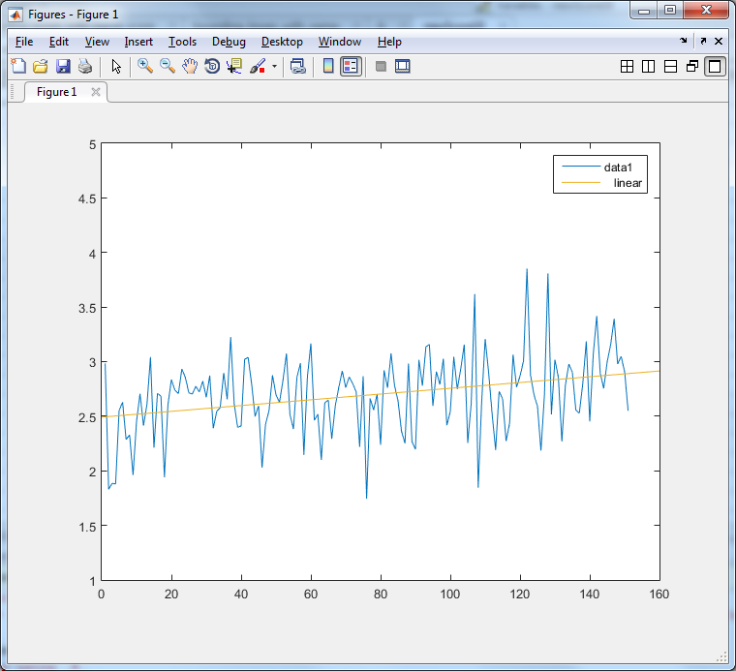

LBP feature /face size 500 /window Size 18*18 /lambda 0.01 /calculated landmark

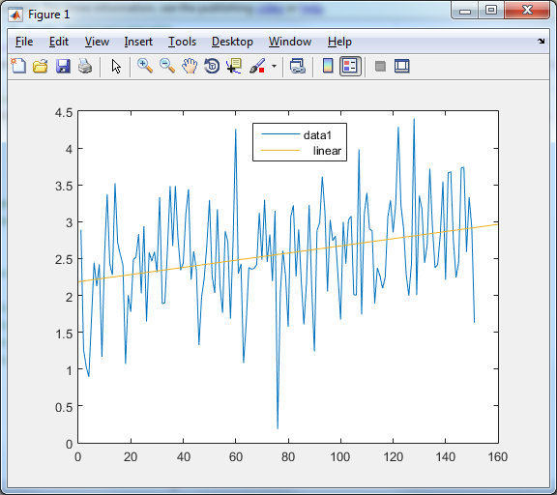

LBP feature /face size 500 /window Size 18*18 /lambda 0.01 /ground truth



Female results

Result ground truth

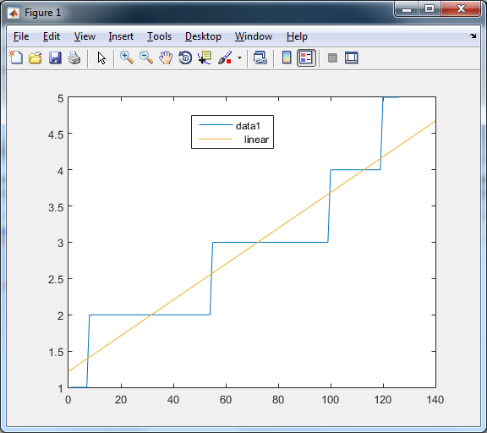

1. LBP feature /face size 500 /window Size 18*18 /lambda 0.01 /ground truth landmark

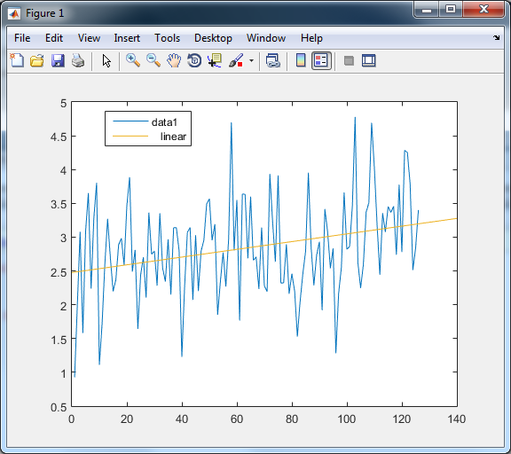

error_75 =

0.8965

error_50 =

0.8862

error_30 =

0.8774

error_20 =

0.8747

error_18 =

0.8746

error_13 =

0.8763

error_10 =

0.8795

error_5 =

0.8946

error_1 =

0.9438

error_01 =

0.9790

error_001 =

0.9843

Female HoG feature /face size 500 /window Size 18*18 /lambda 14 /ground truth landmark

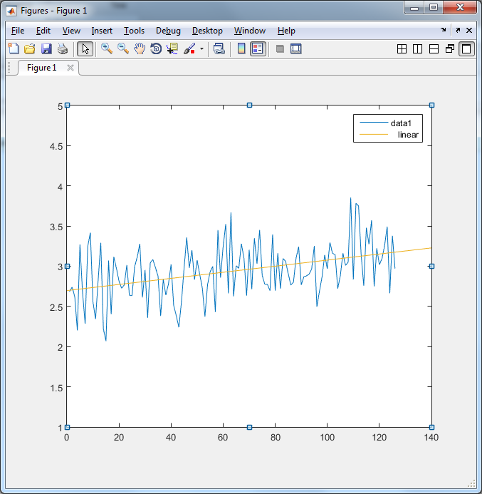

Female HoG feature /face size 500 /window Size 18*18 /lambda 0.01 /ground truth landmark

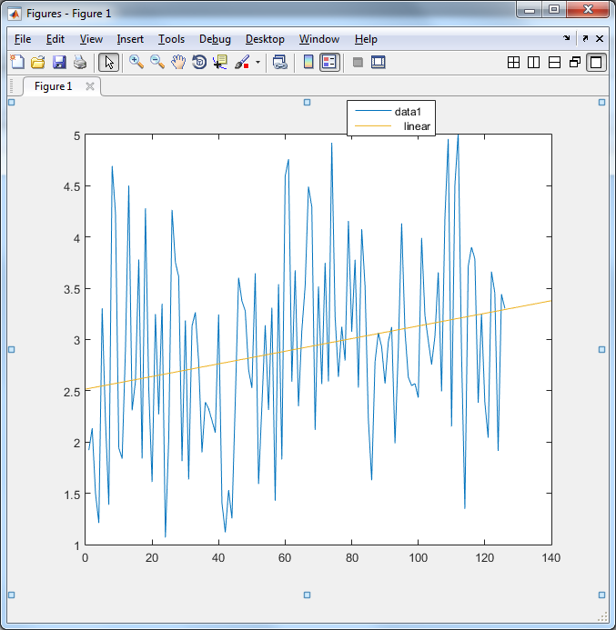

error_75 =

0.9156

error_50 =

0.9052

error_30 =

0.8942

error_20 =

0.8887

error_13 =

0.8872

error_10 =

0.8890

error_5 =

0.9049

error_1 =

0.9962

error_01 =

1.1174

error_001 =

1.1434